- Analysis of all the visualizations with respect to how it is helping you find the Key Performance Indicators and the causes of various problems identified.

As exemplified below, the revenue of all three locations was very similar until end of January. But after that Upper West side experienced a great increase, Brooklyn remaing stable and Lower Manhatan had reduced its revenue.

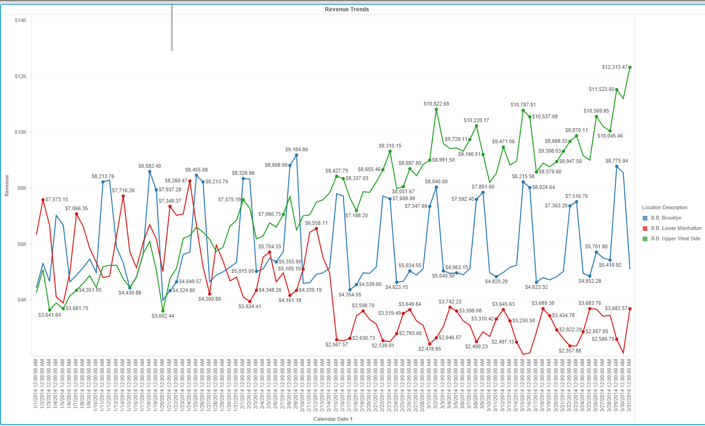

The HeatMap below demonstrates that Upper West Side has the biggest average revenue, followed byBrookly. Also that weekends have the biggest share of the average revenue
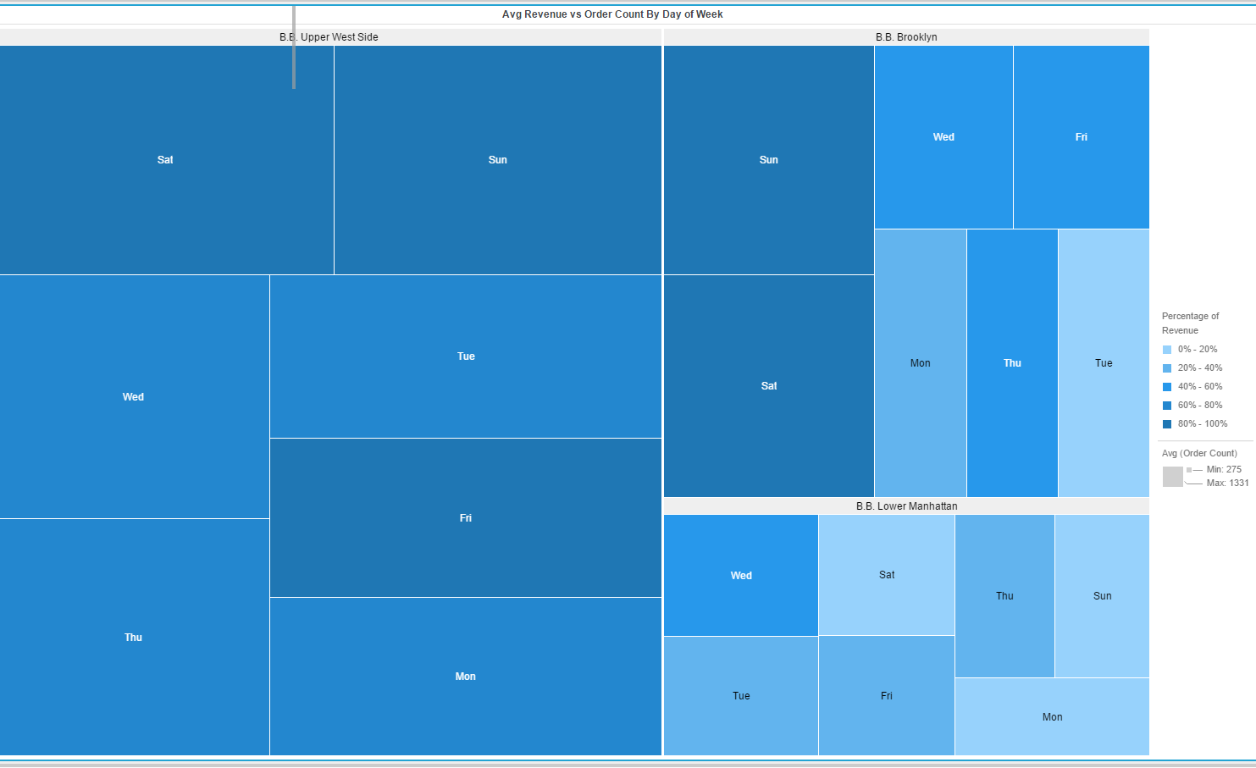

- What more could you have done other than what is included in the exercise to achieve better analysis of both the datasets?
Its clearly that Upper West Slide restaurant gets most revenue on Saturday and Sunday.
It should try to attract customers in Lower Manhattan on Saturday and Sunday by giving some offers.

